**Resource Group**

1. Go to Resource group.

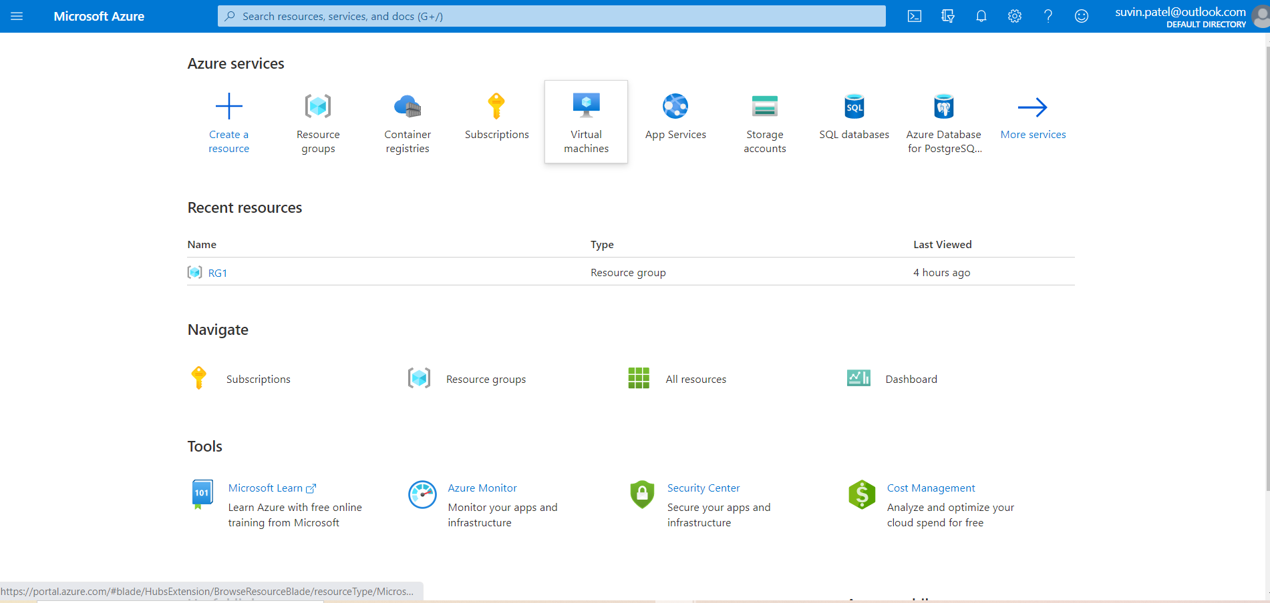

1. Click on add to add new Resource group.

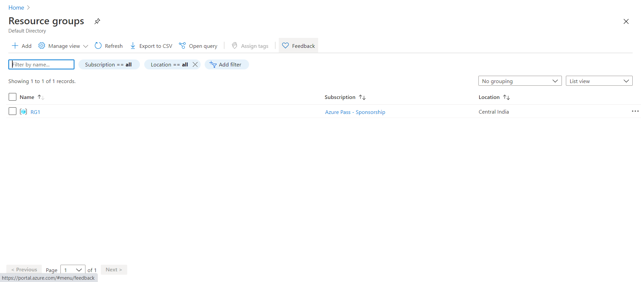

1. Give name and select region. Then select Create + Review option.

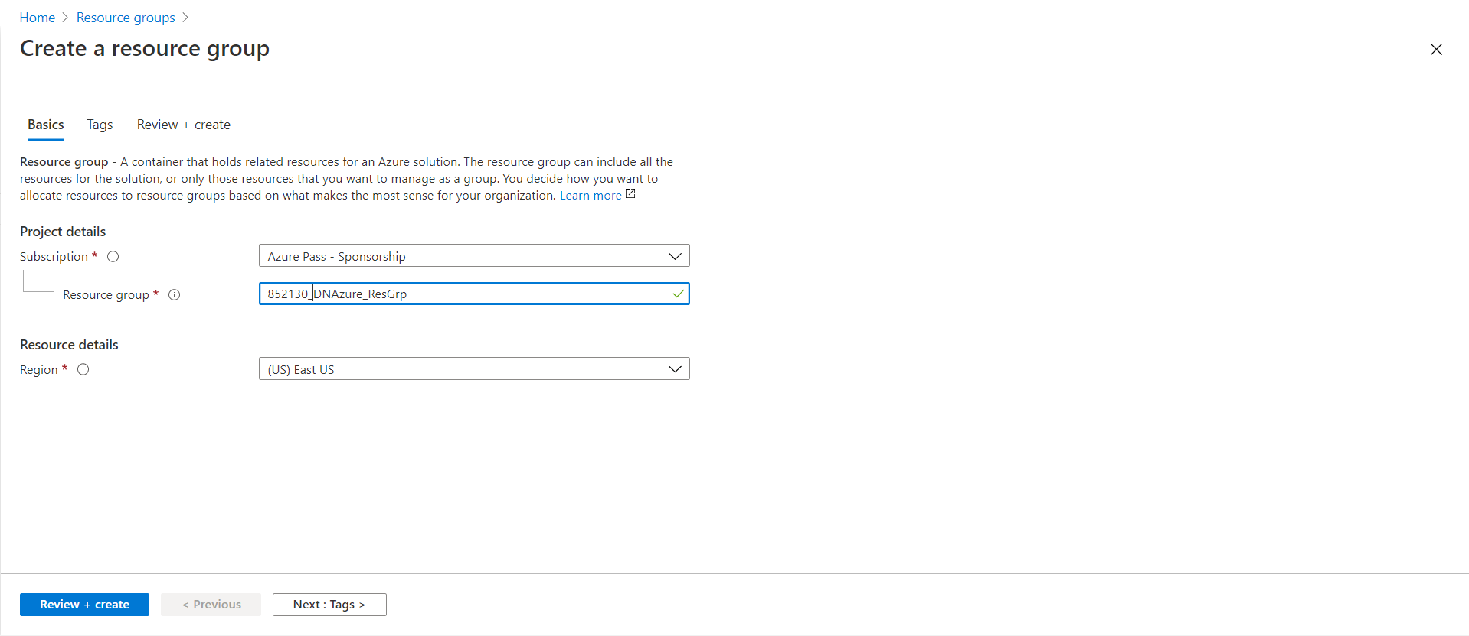

1. Review you resource group and click Create.

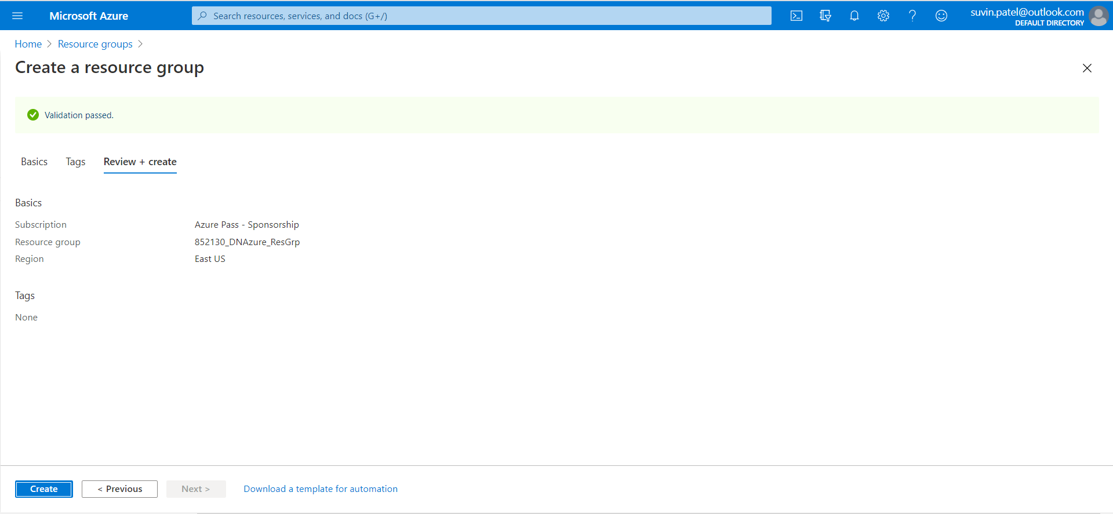

1. Resource group is created.

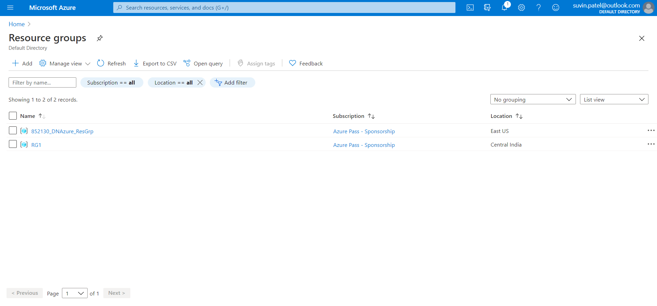

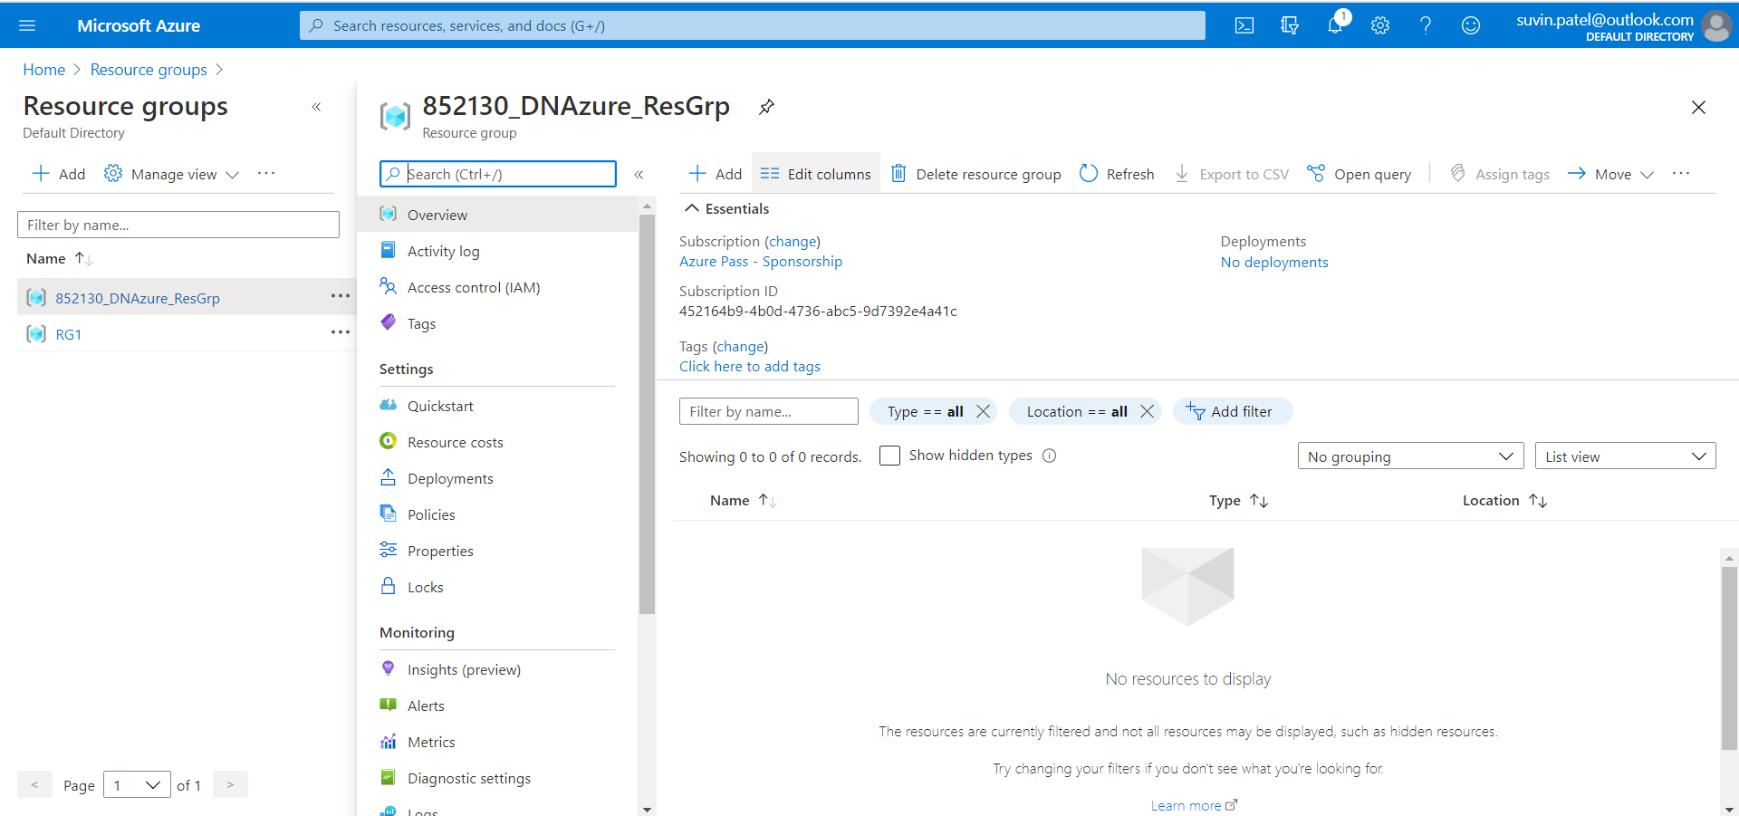

**Container Registry**

1. Select Container Registry and click on Add.

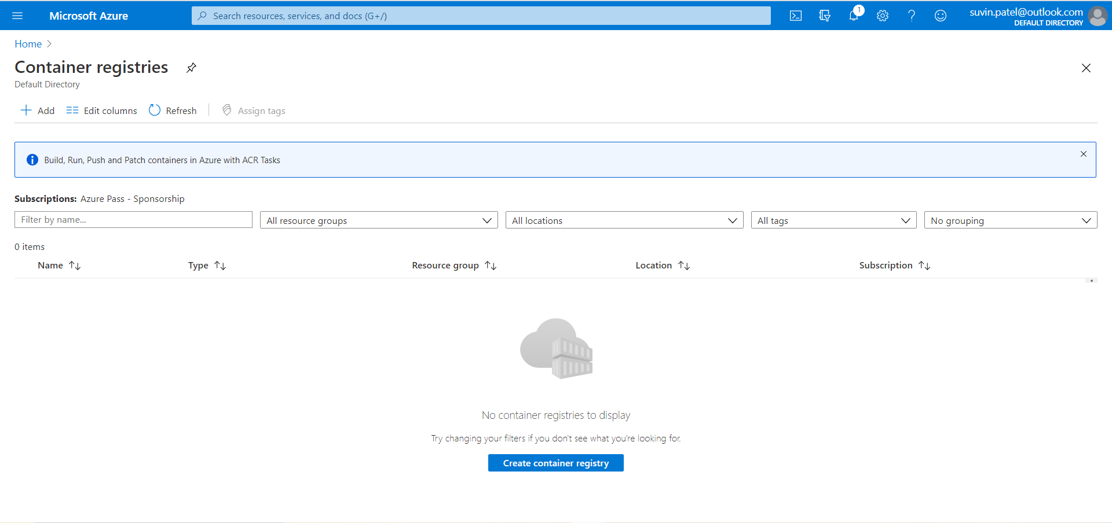

1. Give name, resource group and other information and select Review + Create.

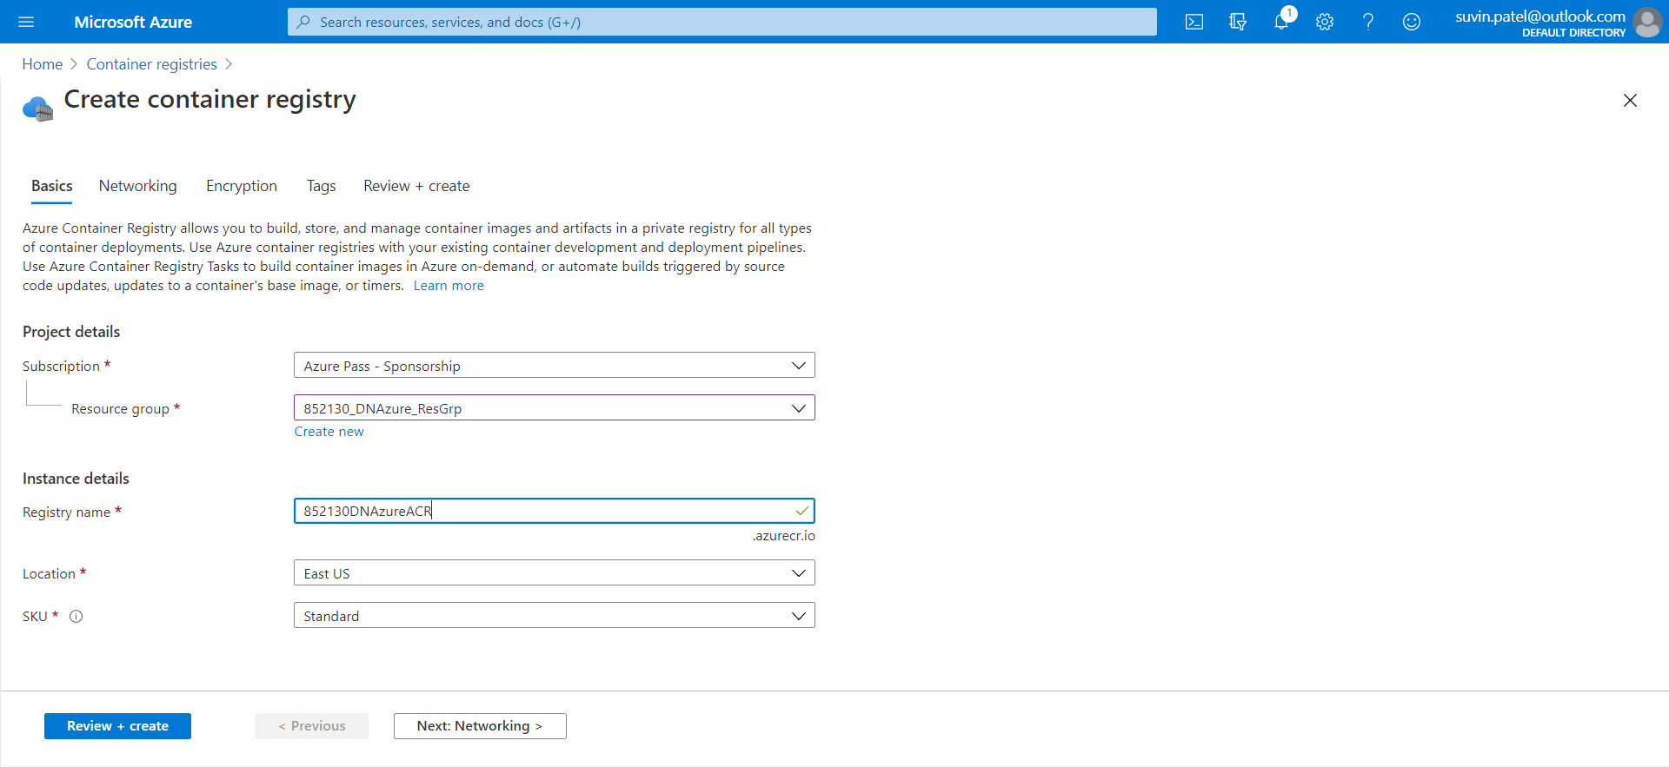

1. Review the Container Registry and click Create.

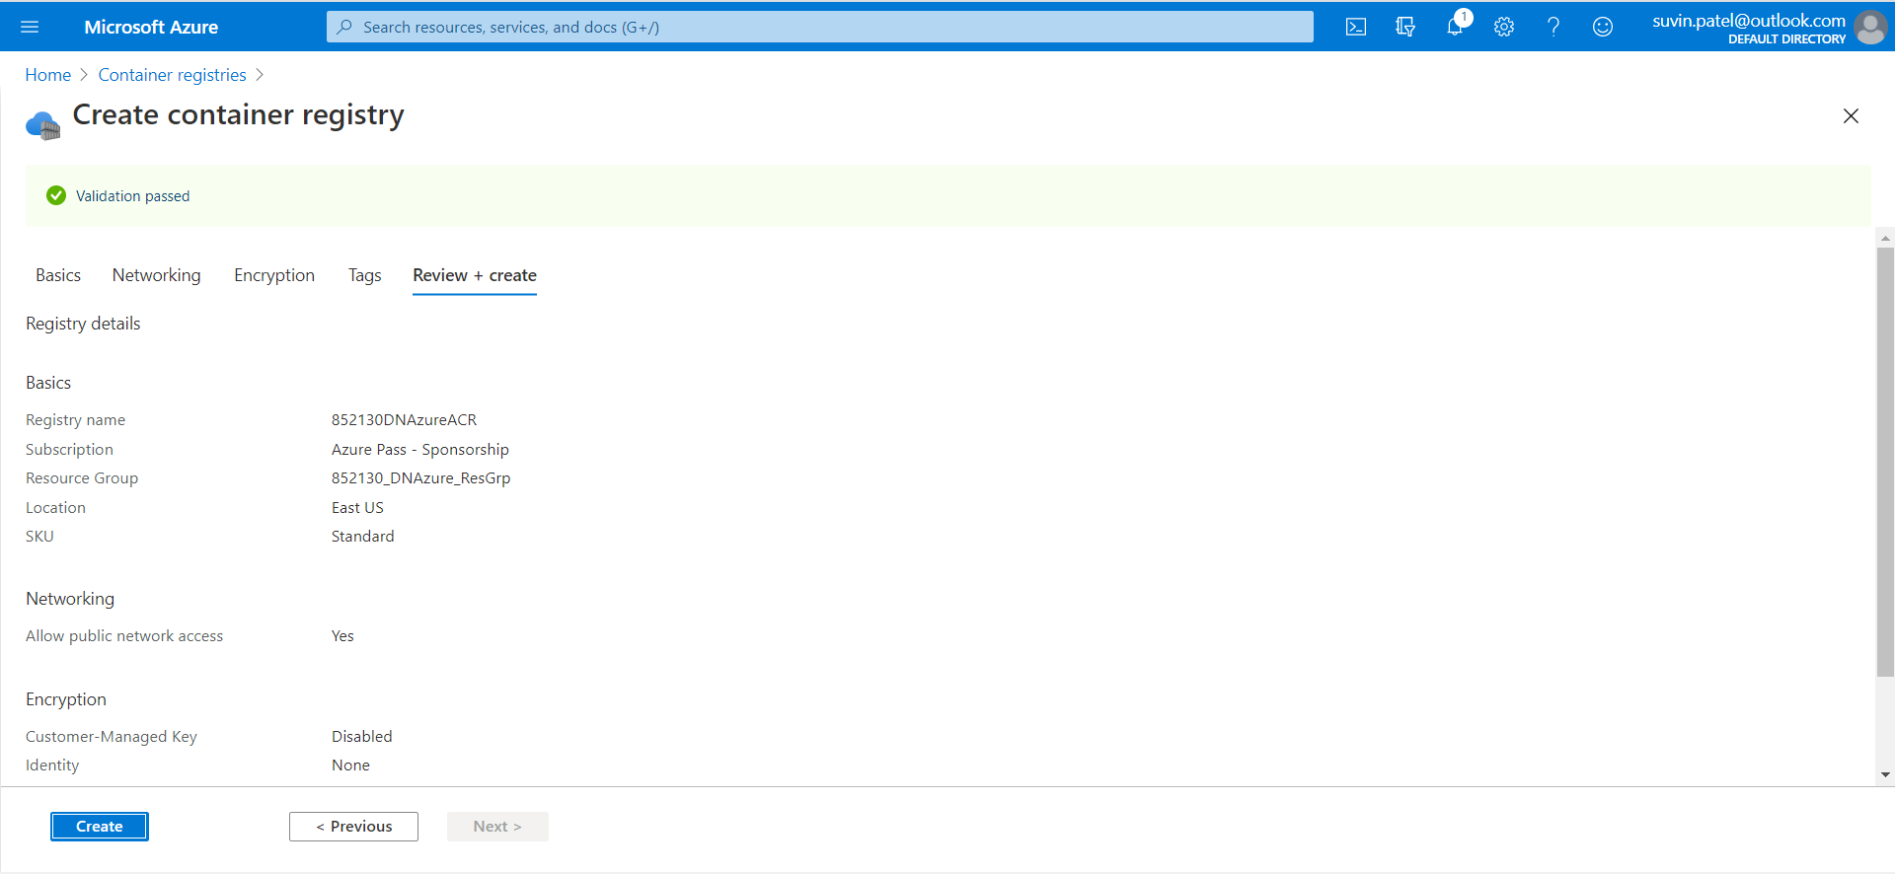

1. Container Registry is created.

